EXERCISE-2

REST - Country Web Service
Code:
pom.xml
<?xml version="1.0" encoding="UTF-8"?>
<project xmlns="http://maven.apache.org/POM/4.0.0"
xmlns:xsi="http://www.w3.org/2001/XMLSchema-instance"
xsi:schemaLocation="https://maven.apache.org/POM/4.0.0 https://maven.apache.org/xsd/maven-4.0.0.xsd">
<modelVersion>4.0.0</modelVersion>
<parent>
<groupId>org.springframework.boot</groupId>
<artifactId>spring-boot-starter-parent</artifactId>
<version>3.5.4</version>
<relativePath/>
</parent>
<groupId>com.cognizant</groupId>
<artifactId>springlearn</artifactId>
<version>0.0.1-SNAPSHOT</version>
<properties>
<java.version>21</java.version>
</properties>
<dependencies>
<dependency>
<groupId>org.springframework.boot</groupId>
<artifactId>spring-boot-starter-web</artifactId>
</dependency>
</dependencies>
<build>
<plugins>
<plugin>
<groupId>org.springframework.boot</groupId>
<artifactId>spring-boot-maven-plugin</artifactId>
</plugin>
</plugins>
</build>
</project>

Application.properties
server.port=8083

Country.java
package com.cognizant.springlearn;
public class Country {
private String code;
private String name;
public Country() {
}
public String getCode() {
return code;
}
public void setCode(String code) {
this.code = code;
}
public String getName() {
return name;
}
public void setName(String name) {
this.name = name;
}
}

CountryController.java
package com.cognizant.springlearn.controller;
import com.cognizant.springlearn.Country;
import org.springframework.beans.factory.annotation.Autowired;
import org.springframework.web.bind.annotation.RequestMapping;
import org.springframework.web.bind.annotation.RestController;
@RestController
public class CountryController {
@Autowired
private Country country;
@RequestMapping("/country")
public Country getCountryIndia() {
return country;
}
}

SpringLearnApplication.java
package com.cognizant.springlearn;
import org.springframework.boot.SpringApplication;
import org.springframework.boot.autoconfigure.SpringBootApplication;
import org.springframework.context.annotation.ImportResource;
@SpringBootApplication
@ImportResource({"classpath:country.xml"})
public class SpringLearnApplication {
public static void main(String[] args) {
SpringApplication.run(SpringLearnApplication.class, args);
}
}

Country.xml
<?xml version="1.0" encoding="UTF-8"?>
<beans xmlns="http://www.springframework.org/schema/beans"
xmlns:xsi="http://www.w3.org/2001/XMLSchema-instance"
xsi:schemaLocation="
http://www.springframework.org/schema/beans
https://www.springframework.org/schema/beans/spring-beans.xsd">
<bean id="country"
class="com.cognizant.springlearn.Country">
<property name="code" value="IN"/>
<property name="name" value="India"/>
</bean>
</beans>

Output:
1: Spring Boot Application Startup
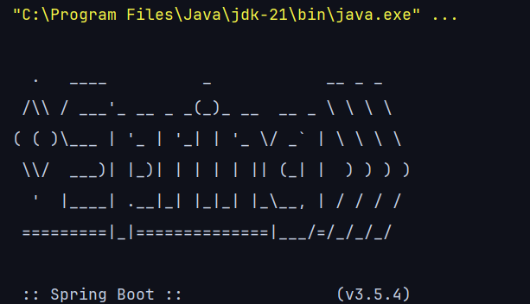

2: Browser Request
URL-http://localhost:8083/hello
Response:
